ASSIGNMENT – 1

Ques 1. Explain the difference between frontend, backend, and full-stack development with
suitable real-world examples.

Ans = Frontend, Backend, and Full-Stack Development
Frontend:
- Deals with what users see and interact with.
- Technologies: HTML, CSS, JavaScript, React.
- Example: Product pages, buttons, forms on Amazon.
Backend:
- Handles server-side logic, databases, and application functionality.
- Technologies: Java, Python, Node.js, SQL.
- Example: Updating cart, managing orders, storing user data on Amazon.
Full-Stack:
- Combines frontend and backend skills.
- Can build complete web apps from UI to database.
- Example: Netflix – interface + streaming servers + user data management.

Ques 2. Create a simple diagram showing how the client-server model works in web architecture.

Ans = 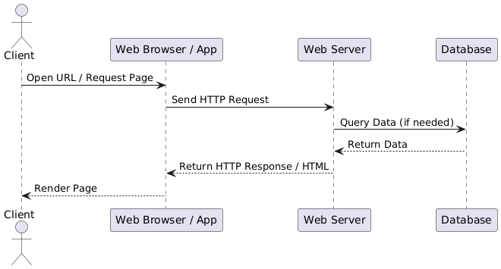

Ques 3. Describe how a browser requests and displays a web page from a web server.

Ans = A Browser Requests and Displays a Web Page as follows-:
User Request:
- The user enters a URL in the browser or clicks a link.
- The browser translates the URL into an IP address using DNS (Domain Name System).
- Sending HTTP Request:
  - The browser sends an HTTP/HTTPS request to the web server hosting the website.
  - The request includes information like browser type, cookies, and the page/resource being requested.
- Server Processing:
  - The web server receives the request.
  - It processes it by checking static files (HTML, CSS, JS) or running backend logic if the page is dynamic.
  - If required, the server queries a database to retrieve or store data.
- Server Response:
  - The server sends back an HTTP response, usually containing HTML, CSS, JavaScript, and other resources.
  - Response may include status codes (e.g., 200 OK, 404 Not Found).
- Rendering the Page:
  - The browser parses the HTML, builds the DOM (Document Object Model), and applies CSS for styling.
  - JavaScript is executed to make the page interactive.
  - External resources like images, fonts, or APIs are loaded.
- Display to User:
  - The browser renders the final web page on the screen.
  - User can now interact with the page, triggering further requests if needed.

Ques 4. Identify and list the tools required to set up a web development environment. Explain the purpose of each.
Ans = Tools Required for Web Development Environment
- Code Editor / IDE
  - Examples: VS Code, Sublime Text, IntelliJ IDEA
  - Purpose: To write and edit HTML, CSS, JavaScript, and backend code efficiently.
- Web Browser
  - Examples: Chrome, Firefox, Edge
  - Purpose: To test, debug, and render web pages during development.
- Version Control System
  - Example: Git + GitHub/GitLab
  - Purpose: To track code changes, collaborate with others, and manage project versions.
- Package Manager
  - Examples: npm (Node Package Manager), Yarn
  - Purpose: To install, manage, and update external libraries and dependencies.
- Local Development Server / Backend Tools
  - Examples: XAMPP, WAMP, Node.js with Express
  - Purpose: To run dynamic web applications locally and simulate server behavior.
- Database Management System
  - Examples: MySQL, PostgreSQL, MongoDB
  - Purpose: To store, retrieve, and manage data for web applications.
- Browser Developer Tools
  - Built-in in browsers (F12 / Inspect)
  - Purpose: To debug, inspect elements, monitor network requests, and optimize performance.

Ques 5. Explain what a web server is and give examples of commonly used servers.
Ans = Web Server
Definition:
A web server is software or hardware that receives requests from clients (browsers) over the Internet and sends back responses, usually in the form of web pages (HTML, CSS, JS) or data (JSON, XML).
Purpose:
- Hosts websites and web applications.
- Handles HTTP/HTTPS requests and responses.
- Serves static files (HTML, CSS, images) and dynamic content generated by backend applications.
Commonly Used Web Servers:
- Apache HTTP Server – Popular open-source web server.
- Nginx – High-performance web server and reverse proxy.
- Microsoft IIS (Internet Information Services) – Windows-based web server.
- LiteSpeed – Lightweight and fast web server for hosting websites.
Example in Real World:
When you type www.amazon.com in your browser, your request is sent to Amazon’s web server, which returns the HTML, CSS, and JavaScript needed to display the webpage

Ques 6. Define the roles of a frontend developer, backend developer, and database administrator in a project.
Ans = Roles in a Web Development Project
- Frontend Developer
  - Focuses on what users see and interact with.
  - Designs and implements the user interface (UI) using HTML, CSS, JavaScript, and frameworks like React or Angular.
  - Ensures the website is responsive, interactive, and visually appealing.
- Backend Developer
  - Handles the server-side logic, APIs, and application functionality.
  - Works with programming languages like Java, Python, Node.js, or PHP.
  - Connects the frontend to databases and manages data flow and security.
- Database Administrator (DBA)
  - Designs, manages, and maintains the database for the application.
  - Ensures data integrity, performance, and security.
  - Handles database queries, backups, indexing, and optimization.
Summary:
- Frontend → User interface & experience
- Backend → Application logic & server processing
- DBA → Database management & data integrity

Ques 7. Install VS Code and configure it for HTML, CSS, and JavaScript development. Take a screenshot of the setup.
Ans = 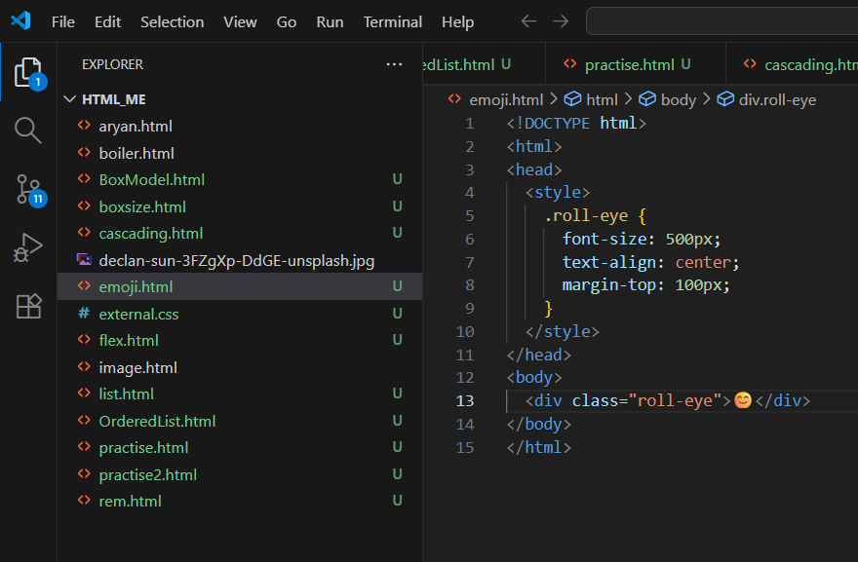

Ques 8. Explain the difference between static and dynamic websites. Provide an example of each.

Ans = Static vs Dynamic Websites
1. Static Websites:
- Definition: Pages are fixed and display the same content to every user.
- Technology: HTML, CSS, and simple JavaScript (no server-side processing).
- Characteristics:
  - Content does not change unless manually updated.
  - Fast loading, easy to host.
- Example: Personal portfolio, company brochure website.
2. Dynamic Websites:
- Definition: Pages are generated on-the-fly and can show different content based on user interaction or database data.
- Technology: HTML, CSS, JavaScript + backend languages (PHP, Java, Node.js) + database.
- Characteristics:
  - Content changes automatically based on user, time, or other conditions.
  - More complex and interactive.
- Example: Facebook, Amazon, YouTube.
Summary:
- Static → Fixed content, simple, fast.
- Dynamic → Interactive, database-driven, personalized content.

Ques 9. Research and list five web browsers. Explain how rendering engines differ between them.
Ans = Web Browsers and Rendering Engines
1. Google Chrome
- Rendering Engine: Blink
- Notes: Fast, widely used, supports modern web standards.
2. Mozilla Firefox
- Rendering Engine: Gecko
- Notes: Open-source, focuses on privacy and developer tools.
3. Microsoft Edge
- Rendering Engine: Blink (Chromium-based)
- Notes: Modern replacement for Internet Explorer, integrates with Windows.
4. Safari
- Rendering Engine: WebKit
- Notes: Default browser for macOS and iOS, optimized for Apple devices.
5. Opera
- Rendering Engine: Blink
- Notes: Known for built-in VPN, ad blocker, and performance optimization.
Difference Between Rendering Engines:
- A rendering engine interprets HTML, CSS, and JavaScript to display web pages.
- Different engines may handle CSS, JavaScript, or animations slightly differently, affecting performance and layout.
- Example: Gecko (Firefox) may render some CSS properties differently than Blink (Chrome/Edge).
- Web developers often test websites across multiple browsers to ensure compatibility.

Ques 10. Draw a labeled diagram showing the basic web architecture flow — client, server, database, and APIs.

Ans = 